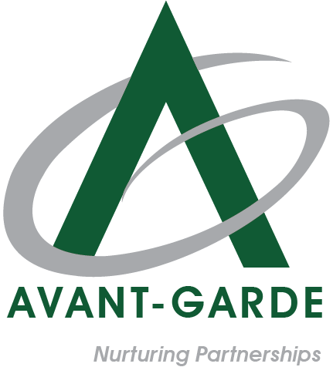
Avantgarde Annual Appraisal Form
Confidential / Internal Use Only

Employee Information and Performance Evaluation Form
(This form is to be used for the Annual Performance Appraisal process 2025 and will be completed by the employee and the reporting manager as applicable.)
Section A: Employee Details
Employee Name:
Employee ID:
Designation:
Department:
Date of Joining:
Country / Location:
Reporting Manager:
Department Head / Country Head:

Section B: Employee Self-Assessment – Key Performance Indicators (KPIs)
S. No. | Key Result Area (KRA) & Key Performance Indicators (KPI)  (State your main deliverables or focus areas for the year) | Key Achievements / Results  (Summarize the results achieved during the year) | Employee Rating  (1-5) | Department Head / Reporting Manager Comments | Department Head / Reporting Manager Rating (1-5)

Soft Skills | Guiding Description (for reference Only) | Employee Self-Rating (1-10) | Department Head / Reporting Manager Rating (1-10)
Communication | Communicates clearly and professionally with colleagues, customers, and stakeholders.
Teamwork & Collaboration | Works effectively with others and contributes positively to team goals.
Accountability & Ownership | Takes responsibility for assigned tasks and ensures work is completed as expected.
Professional Conduct | Demonstrates professionalism, respect, and appropriate workplace behavior.
Adaptability & Flexibility | Adjusts effectively to changes in work, priorities, or environment.
Initiative & Proactiveness | Shows willingness to take initiative and go beyond assigned responsibilities when required.
Problem-Solving Ability | Approaches challenges logically and contributes to effective solutions.
Time Management & Discipline | Manages time effectively and meets deadlines consistently.
Quality & Attention to Detail | Maintains accuracy and quality in work outputs.
Integrity and Work Ethics | Acts with honesty, reliability, and adherence to company values.
Overall Rating |  | /100 | /100

Section C: Employee Summary and Development Plan
Item | Description / Employee Input
Overall Performance Summary (Briefly summarize your performance and contribution during the year.)
Challenges Faced (Mention key obstacles or situations that affected your performance and how you managed them.)
Areas of Improvement / Development (Identify skills or areas you wish to improve in the next review period.)

Training / Support Required (Specify if any training, mentoring, or support is needed from the organization to enhance your performance.)
Employee Signature & Date

Section D: Manager Assessment – Overall Performance Evaluation
Evaluation Area | Manager Comments / Summary and Rating (1–5)
Overall Achievement of KPIs (Summarize the employee’s performance across all KPIs (e.g., met expectations, exceeded in certain areas, or needs improvement).
Manager’s Final Overall Rating (1–5) (Provide your overall performance rating for the employee)
Manager’s Recommendation (Indicate if the employee is ready for higher responsibility, needs development, or is a consistent performer.
Reporting Manager Signature & Date

Section E: HR Review & Finalization (HR Use Only)
HR Review & Finalization Table
Item | HR Input / Observation
Soft Skills KPI Rating - Post Mapping (Derived from soft skills rating table after percentage-to-KPI mapping)
Overall KPI Rating - As per Manager Assessment (Overall KPI rating provided by the Reporting Manager / Department Head)
Calibration Adjustment (If Any) (Yes / No – Brief rationale if adjusted)
Revised Overall KPI Rating - Post Calibration (Final KPI rating after leadership calibration)
HR Observations / Remarks
Final Performance Rating - For Internal Records (Confirmed final rating)
Eligible for Salary Increment (Yes / No)
Eligible for Annual Bonus (Yes / No)
Special Notes (If Any)

